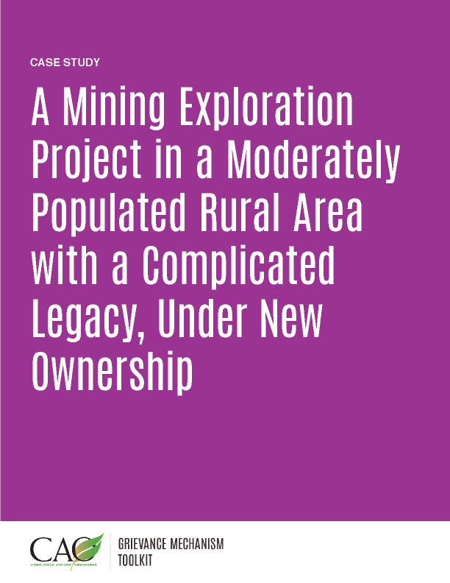

Last updated: May 2016

The following case study is a fictionalized version of an actual situation encountered by experts in the field. While it is based on real experiences, it is not intended to depict any particular location or company.

Creating Trust and Generating Sustainable Benefits

OmniCorp is a mid-sized mine developer and operator that purchased OroSol, a small, locally owned gold producer in South America. OmniCorp has clear corporate environmental and social standards and frequently sought financing from Equator Banks, which have voluntarily agreed to help uphold environmental and social standards for the projects they finance. Thus, the company was very familiar with international standards for community consultation, engagement, grievance management, and land access.

As a small, local company, OroSol did not apply international standards during exploration and operation, but rather conformed to national standards that were not well specified or enforced. Land access was particularly problematic, as title was often uncertain and much land was owned and/or managed collectively. Indeed, land access was a major focus of OroSol and tended to be the most raised social issue. OroSol wanted to work with community members on land issues, and viewed the best approach to be focused on compensation for access and impacts. This approach had served the company well in the past, as evidenced by the rapid expansion of the mine over the past five years, to the point that it became an attractive acquisition target for OmniCorp. Disputes over land access had been increasing recently, and the costs of new land were escalating, so OroSol entered discussions about its acquisition by OmniCorp with the hope that the greater technical resources and range of approaches and resources available with the new company would help it with land issues.

Setting up the Grievance Mechanism

OmniCorp management realized that it was critical to address the land issue early on. OroSol’s pay-as-you-go approach was not sustainable and was not aligned with corporate policy or the international standards that applied to the loan OmniCorp received to buy OroSol. OmniCorp decided to end the pay-as-you-go approach and implement a more comprehensive and proactive grievance mechanism.

The grievance mechanism followed OmniCorp’s corporate-level template and was implemented shortly after it took over OroSol. OmniCorp hired three Community Liaison Officers to work with each of the three villages surrounding the mining concession and quickly began discussing the company approach to development and impact management in community forums. The company hoped to make it clear that it would focus on creating opportunities for local businesses and would apply a more structured approach to managing impacts, rather than simply handling out cash.

OmniCorp recognized that although the grievance mechanism could handle the “typical” complaints of community members surrounding a mining project—nuisances from noise, traffic, and dust—the company would need an enhanced process to manage the land issues. It chose to use the grievance mechanism as the first point of entry for land concerns, but realized that most land complaints would require some sort of appeals process, at least in the beginning and until trust could develop. So it created an Independent Land Arbitration (ILA) Committee composed of the company’s site-level external affairs manager, each of the mayors of the three surrounding villages, and the regional director of energy and mines. If a complainant was not satisfied with the resolution proposed using the grievance mechanism, he or she could choose to take the complaint to the ILA Committee. In this way, the complaint received a fair and impartial hearing from a committee composed of people with multiple perspectives.

The new system had a rocky start. The transition from a compensation-oriented approach for impact management and land access to a more structured approach that was focused on creating local economic benefits and managing impacts more equitably was difficult. Many community members viewed this change as a step backward, as it meant a shift from the certainty of receiving money when they expressed a concern to the uncertainty of a more structured process they did not understand or even trust in the beginning.

Over time, however, the strategy began to work. A key component of this success was OmniCorp’s focus on creating local benefits and fostering opportunities for small businesses. In this way, people could see the economic benefit of the company presence and came to understand that they would receive more sustainable benefits. The ILA Committee was another key factor, as it was viewed as a credible and trusted way to address land issues that had been a problem since the project began.

