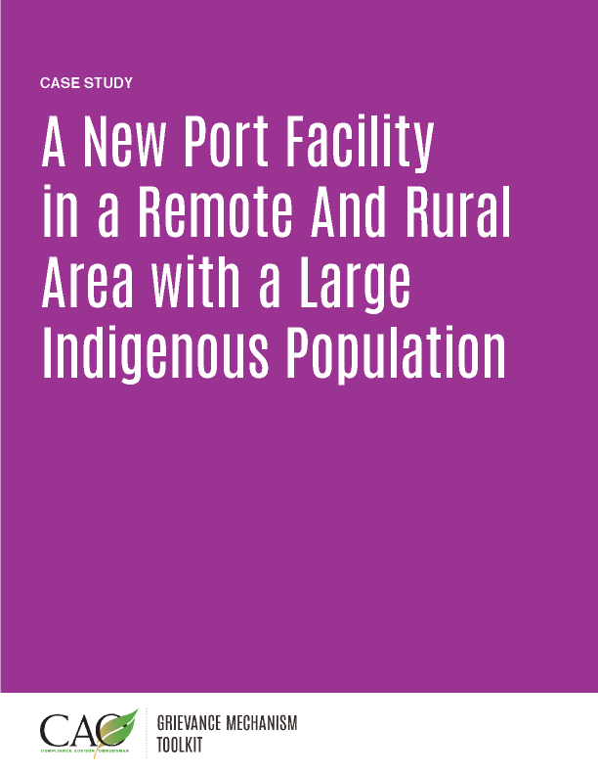

The following case study is a fictionalized version of an actual situation encountered by experts in the field. While it is based on real experiences, it is not intended to depict any particular location or company.
Tailoring an Approach to Different Community Concerns and Needs
WorldPorts is developing the Docklands, a port and shipping facility for minerals and agricultural products off the coast of a southern African country. WorldPorts received a loan from a multilateral investment bank to develop the port infrastructure, so they must comply with international standards for social and environmental impact assessment and management.
Port construction will require a workforce of approximately 5,000 people, many of whom will be brought in from other parts of the country. Construction will be conducted by a contractor of a large international company, Engineering, Procurement, and Construction Management (EPCM) International. Construction will take three years; during this period, construction workers will live in a camp near the port facility.
The project is located in a remote coastal area where people predominantly engage in subsistence fishing and agriculture. A large proportion of the community is an ethnic minority that is not legally recognized as indigenous by the government. They are identified as “vulnerable people” in project impact assessment documentation and do not appear to have title to land in the area. The main economic activity of this group is fishing.
A second group of people own land in the area, which they use for small-scale farming. They are more assimilated into the dominant culture, and many of the young people from this community leave to gain a better education and employment in the capital.
Setting up the Grievance Mechanism
WorldPorts recognizes that the construction project will bring a large workforce to the area for a relatively short period of time, and that activities could result in negative impacts on the local population. Therefore, they required EPCM International to develop, implement, and manage a grievance mechanism that conforms to international standards. EPCM International has some experience with grievance mechanisms and assigned its community engagement expert, Mr. Smith, to develop a project-specific mechanism for the Docklands project.
Mr. Smith had a template grievance mechanism that EPCM had used on other projects, but recognized the complexity of the local community and understood that he must engage in consultation as part of development of the grievance mechanism. He convened a series of meetings with fishermen to understand their concerns and get a better feel for how they manage disputes in their highly traditional society. Several concerns were brought to light during the consultation:
- The fishing community is concerned that access to traditionally used fishing areas near the coast will be restricted during and after construction. Fishermen in the area use small boats and are not able to travel the long distances that may be required if access is restricted.
- Women traditionally have sold fish in an informal dock area to people from the farm community. They are worried that they will not be able to find another location to sell their fish.
Consultation with the farming community revealed a different set of concerns:
- Farmers would like more employment opportunities for young people from the area, so that they have a better chance of staying and not migrating to the capital.
- They are worried about new people coming to the area and the societal changes this will inevitably bring, including generating class differences, increased crime, and drug use.
- They have heard that the company has conducted “special meetings” with the fishermen and are worried that fishermen will receive special treatment. They view the fishermen as always looking for a handout and don’t like the idea that the company will perpetuate this.
Based on the consultations, Mr. Smith realized that the two distinct populations will need different resources and approaches to grievance management. He decided to develop one grievance mechanism process, but manage engagement around the process differently for the two groups.
The concerns of the fishing community primarily relate to maintaining their traditional means of livelihood, and Mr. Smith anticipates that most of their concerns will center on access to land and sea. The concerns of the farming community primarily relate to creating opportunities around employment, the potential for societal change, and concern that the project will make them go “backward” from their current situation and in comparison to the fishing community.
Mr. Smith implemented a grievance mechanism process for both communities and made it clear in public meetings that there would be a single process for managing community concerns, but with a distinctly different form of consultation for each community:
- For the fishing community, he hired a fisheries liaison officer (FLO) to serve as the primary contact. The person hired was from the community and previously worked for the Department of Fisheries in the capital. He also convened a Council of Elders, composed of senior community members who are no longer actively working, to serve as an appeals committee should a resolution not be agreed upon.
- For the farming community, he hired a community liaison officer (CLO) who worked previously with a local nongovernmental organization. The CLO served as the primary point of contact for community inquiries (around employment and contracting opportunities) as well as for the grievance mechanism.
Mr. Smith held weekly meetings with the FLO and CLO to exchange information and to ensure that consultation and grievance handling was consistent and fair. During these meetings, they prepared a weekly consultation and grievance mechanism report for EPCM management. This report was also provided on a quarterly basis to WorldPorts for inclusion in the contractually obligated quarterly report to the project lender.
Early consultation and implementation of the grievance mechanism was critical to project success. The decision to have a dedicated FLO and CLO for each community on the job before construction began helped the project and grievance mechanism gain trust with the communities.
The approach to engagement and grievance management at the Docklands became the gold standard for how WorldPorts aspired to address community issues in all its global operations. The FLO/CLO model was incorporated into the company’s standard operating procedures and became known in the industry as a best-in-class approach.

