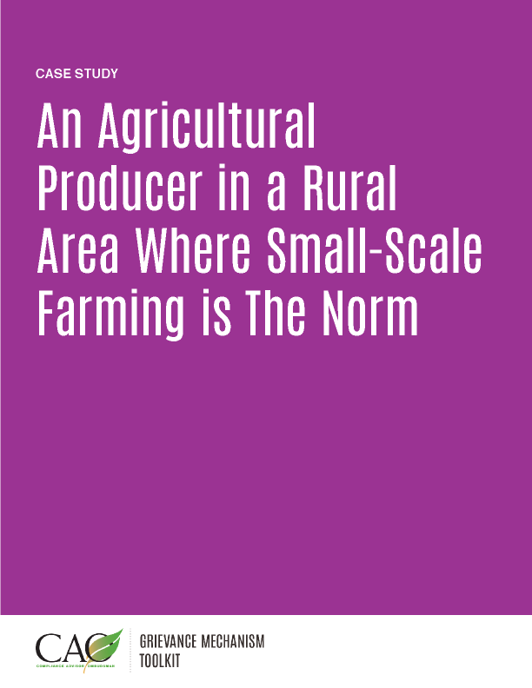

Last updated: May 2016

The following case study is a fictionalized version of an actual situation encountered by experts in the field. While it is based on real experiences, it is not intended to depict any particular location or company.

Creating Mutual Benefits for the Community and the Company

Agripro Industries, a multinational producer of grain crops, purchased a local company with a large land position in rice production in a rural area in southeast Asia. The company fields are surrounded by small-scale, subsistence-level producers that had coexisted with the local company for many years. The production methods of the local producer were not that different from those of the subsistence farmers, and the boundaries of fields, access roads, and water supplies were very lightly patrolled and regulated. Indeed, encroachment of community members on the fields was quite normal, to the point where the company fields were viewed as a sort of commons for local community members (and a good place to graze water buffalo).

One aim of the purchase was to modernize and increase production from the fields. To do this, Agripro wanted to tightly regulate access to the private land and infrastructure they now owned, including fields, roads, irrigation canals, and equipment. The project manager for Agripro recognized that the local communities were coming from a position of viewing the land as a communal asset, and that blocking access to lands traditionally used by community members was a recipe for unrest and conflict. So he put his Community Relations Manager, Ms. Li, in charge of developing and implementing a grievance mechanism just after the acquisition was complete.

Setting up the Grievance Mechanism

Ms. Li had heard about grievance mechanisms, but the company had very little internal experience to draw from. She was fortunate early on to find helpful guidance documents written by international development agencies and industry consortia. She found these resources useful but a bit complex, as they typically referred to very high impact activities like mining and oil and gas extraction. She knew in her context, with the resources available to her, she needed an approach that would be simple enough to implement and manage.

Ms. Li implemented the following process:
- Meet with community members early on to help them get to know Agripro as their new neighbor, discuss changes in access that would occur when Agripro started activities, and understand any concerns they might have.
- Communicate concerns learned from community meetings to management.
- Design a simple, four-step grievance mechanism procedure, in consultation with community members:
  - Receive and acknowledge the complaint.
  - Review and evaluate the complaint, including involving technical staff as necessary.
  - Offer and discuss solutions with the complainant, discuss any concerns the complainant might have, and implement if accepted. If not accepted, present the complaint to management for review and possible further action.
  - Close the complaint and monitor the outcome.
Ms. Li also realized that for the grievance mechanism to be successful, she would need to make sure people were aware of it. She knew that the cultural and technological context demanded that most communication be face-to-face. So she held community meetings to advertise the complaints system, as well as face-to-face meetings with village leaders.

Establishing the grievance mechanism soon after the acquisition and before the company started changing operations was key to establishing trust. Community members began using the grievance mechanism shortly after its introduction, and it became a key feature of Agripro’s community engagement strategy. The issues presented to the grievance mechanism were as anticipated and related to changes in land access and use. In the first year of implementation, the complaints profile looks like this:
- Five complaints related to loss of access paths to fields as road access became restricted. These complaints were resolved by working with the complainant to identify, construct, and maintain paths that did not involve using private roads.
- Ten complaints related to loss of access points to irrigation water channels. Alternate access points were developed and provided to the complainants in coordination with the Agripro irrigation engineer.
- Twenty complaints related to capture and delayed return of water buffalo grazing on Agripro land. Agripro identified this as a systemic issue, as the buffalo encroached on cultivated land and destroyed crops, requiring capture, quarantine, and farmer’s loss of access to the buffalo, which require daily milking. Agripro developed a communications program about the importance of restricting access to lands it owned and cultivated. The company and community agreed on a system where all water buffalo were tagged with the owner’s name and contact details. When a buffalo was captured on Agripro land, staff first contacted the owner to fetch the buffalo, rather than quarantine it. In addition to this a “three strikes and you’re out” program was agreed on and implemented, where a water buffalo that was found in Agripro fields for the third time would be captured and quarantined.
Community complaints resulted in significant changes in land access and company operations, as described above. The costs associated with these changes were more than offset by the improved community relations. In this way, AgriPro was able to address the concerns of community members while also reducing costs —a true investment in creating mutual benefits.

