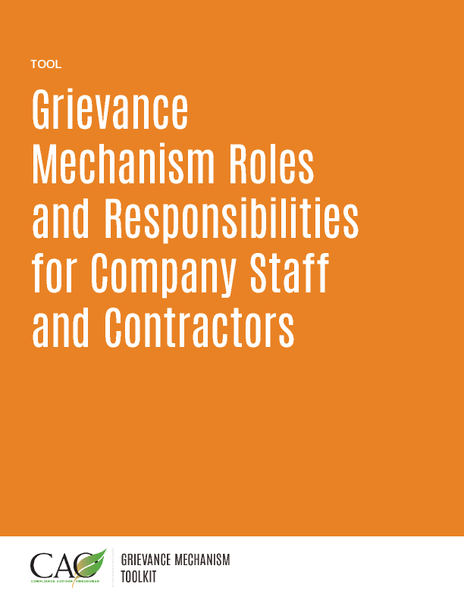

Last updated: May 2016
Roles | Responsibilities
Grievance Officer | - Informs the public about the grievance mechanism.  - Ensures that all individuals with responsibilities under the grievance mechanism are made aware of the existence of the process and receive adequate training.  - Receives and reports complaints.  - Serves as principal point of contact and liaison with complainants.  - Ensures communication with the complainant and follows specified procedures and timelines.  - Maintains a log of complaints received.  - Resolves complaints that do not need a substantive expert.  - Supports the substantive expert, if necessary.  - Serves as a liaison between company and third parties, as required.  - Monitors resolution of complaints.  - Prepares monitoring reports.  - Provides feedback on the effectiveness of the grievance mechanism to management.
Complaint owner | - Responsible for investigating and resolving complaints.  The complaint owner may be either:  - The Grievance Officer, if the complaint can be resolved with limited additional information expertise or resources; or  - A substantive expert, such as a manager from the area of operations implicated by the complaint, if the complaint cannot be easily or quickly resolved by the Grievance Officer.
Appeals Committee | - May be composed of company officials that have not been involved with the complaint to date.  - May also include or be exclusively composed of other trusted people from outside the company, if an independent view is necessary.  - Intervenes when the proposed resolution is not accepted by the complainant and identifies additional actions to address the complaint.  - Approves the close-out of complaints when an agreement cannot be reached with the complainant.
Contractors | - Understand the basics of the grievance mechanism, having received information about and training in the grievance resolution process from the company.  - Assist the complaint owner to manage and resolve complaints in a timely manner when the contractor may be involved.
Project/Operation manager | - Approves and is accountable for implementation of the grievance mechanism.  - Provides support for implementation of the grievance resolution process and enforcement of specific agreements.

