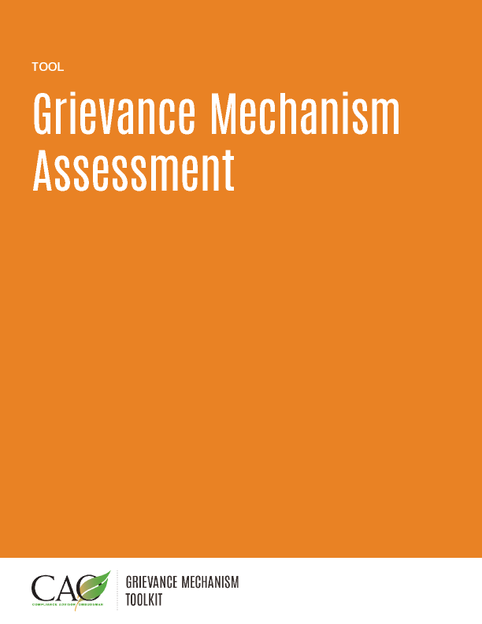

Last updated: May 2016
The following questions allow for a quick assessment of where there may be gaps in the current design and/or implementation of a grievance mechanism. This assessment can help identify potentially critical areas that should be the focus of improvements to the grievance mechanism moving forward, particularly when time is a factor. It is not meant to replace more in-depth grievance mechanism analysis, but rather to help identify areas that may need further analysis. The primary users of this tool would be those conducting project supervision or Grievance Officers taking over an already existing grievance mechanism.
- Do you have a system or structure for collecting complaints or issues raised by the community that relate to your project and its operations?
a) Yes
b) No

- If yes, please describe this system/structure. ______________________________________________________

- Who operates this system/structure?
- Dedicated staff member
- Community Liaison Officer
- There is no specific person assigned
- Other ______________________________________________________

- How do you publicize your mechanism? Select all that apply.
- Local media
- Signage at project site
- Through our Community Liaison Officers/word of mouth
- Brochures
- Other ______________________________________________________

- What are the access channels for complainants? Select all that apply.
- Complaints box
- Hotline
- e-mail
- In-person meetings
- Other ______________________________________________________

- What system do you have for recording grievances? Select all that apply.
- Log book
- Computer database
- We don’t have a system in place
- Other ______________________________________________________

- How many grievances have you received in the last year? ____

- Of the number you gave in question 7, how many have you already resolved? ____

- How do you provide feedback to complainants? Select all that apply.
- In a letter
- At ad hoc community meetings
- At regular community meetings
- At one-to-one meetings
- Other _____________________________________________________

- How do you determine whether complainants are satisfied with the outcome of the grievance mechanism, including the result and the overall process?
  - Through individual surveys at the end of each process
  - Through periodic surveys in the community
  - Informally through discussions with community members
  - Other ____________________________________________________

- How often does management meet to discuss information obtained through the grievance mechanism?
- Every two weeks
- Once a month
- Once a quarter
- Once a year
- As the need arises
- Never

- How does the feedback from the grievance mechanism influence company strategy?
______________________________________________________

