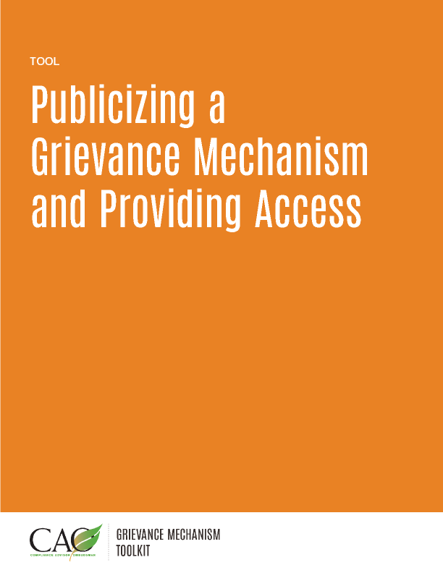

Last updated: May 2016

Increasing effectiveness
In most instances, other than in cases where confidentiality may be requested or fear of reprisal exists, the primary way community members present complaints will be to a company staff person in the community, such as the Grievance Officer. Therefore, fostering staff awareness of and competence in the grievance resolution process is the most valuable investment a company can make. to ensure that a grievance mechanism is working.

Radio, television, and interactive media, such as Facebook and Twitter, have the advantage of making many people aware of the existence of a grievance mechanism. It is important to include contact information in these messages, so that people can follow up in person if they have questions or concerns they wish to discuss.
Print media can be helpful in introducing community members to grievance mechanisms. Leaflets and reference guides in the form of comics can help explain how the grievance resolution process works. It is important to include contact information in these outlets, as follow-up by the grievance mechanism company staff in person will generally be required to answer questions and address concerns.
Providing Proper Access
The most effective access points for the community to the grievance mechanism will depend on the local context, but will always require communication in the local language or dialect. In some cases, people will want to voice their concerns in person and may even want to use a public forum. In other instances, people may fear reprisal from either the company or other community members. Therefore, it is important to have a good mix of confidential, anonymous, semi-public, and public ways to access a grievance mechanism. Some examples of access points include:
- Community Liaison Officers (confidential);
- Complaint hotline (confidential or anonymous);
- Web page (confidential or anonymous);
- E-mail address (confidential or semi-public);
- Text messaging (confidential or semi-public);
- Complaint box in a public area (anonymous, confidential, or semi-public);
- Community leaders (confidential, semi-public, or public); and
- NGOs (anonymous, confidential, semi-public, or public).
The importance of the proper type of access to a grievance mechanism should not be underestimated. Access that is intimidating or inaccessible is ineffective. Companies should avoid grievance mechanisms that are guarded by company security, located on company property where community members are forbidden, or in buildings that are often locked or too far from the community.

