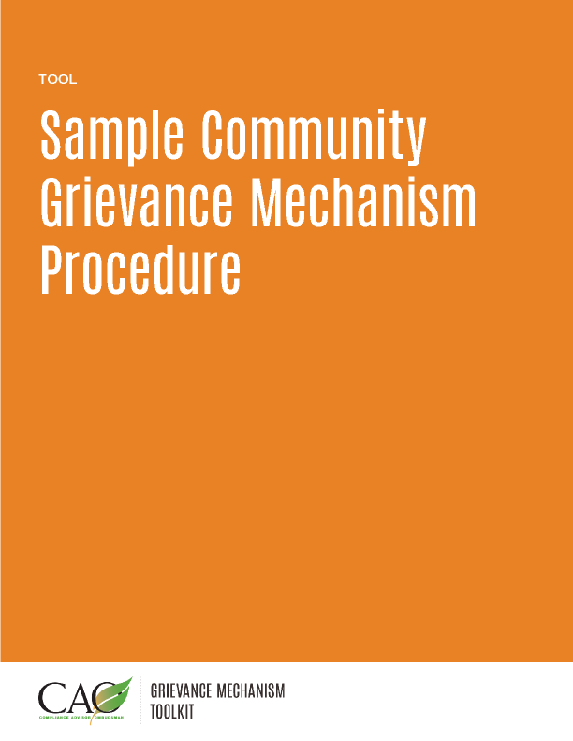

Last updated: May 2016
This sample procedure is meant to serve as a general guide for the type of information that could be provided to the public once tailored to local contexts. One way of doing this is to provide graphic depictions of each step of the process that can be an easy reference guide for potential complainants.
Introduction
This document outlines the Company’s community grievance mechanism, the process for receiving, acknowledging, investigating, resolving, and closing community complaints and grievances (hereafter called “complaints”). The Company views complaints as an important part of managing impacts and encourages community members to submit concerns as they arise. In this way, the grievance mechanism serves as an integral part of the Company’s approach to community engagement and risk mitigation.
Complaints received by the company provide opportunities to inform and improve how the Company conducts business and to learn lessons so that conditions which could lead to similar complaints are prevented in the future. The Company is committed to a consultative, fair, and equitable working relationship with community members who express concerns. The Company is also committed to ensuring that no complainants will be subject to retaliation by either the Company or other community members when they voice their concerns and participate in the grievance resolution process.
This document outlines the complaints procedure, including the steps the Company takes to address community complaints.
Scope of complaints
A person or group can raise a complaint to the Company if they believe Company activities are having an impact on them, the community at large, or the environment.

The Company will evaluate all complaints received and will provide a response. Some complaints may be related to factors not connected to the Company. In these cases, the Company will send a written explanation of why it feels the complaint does not require further action by the Company. In all other cases, the Company will investigate the complaint and determine whether the Company is responsible for or has contributed to the issues that led to the complaint. If the investigation finds the Company has failed to comply with the standards to which it is legally held and/or to which it has committed, or if the Company finds there are unintended or unforeseen impacts that have not been properly mitigated, the Company will identify options for resolution and present an approach to the complainant. The Company will further work to identify measures that could prevent the issue from recurring.
Registering a complaint
Complaints are accepted verbally or in writing. There are several ways community members can register a complaint:
- Contact a Community Liaison Officer at the Company office. The office is open during normal business hours.
- Fill out a complaint form (see form below) and mail or hand deliver to the Company office.
- Call the Company office (xxx-xxx-xxxx) and speak to a Company representative during office hours or leave a message. A Community Liaison Officer will respond to all inquiries and messages within 48 hours.
- Send an email to complaints@Company.com

If the issue needs attention immediately, please call the Company emergency hotline, xxx-xx-xxxx.
The complainant should provide as much information about the concern as possible when presenting the complaint, including copies of any relevant documents or photos.

The Procedure
In some instances, such as when a complaint is more of a question or request for information, the Company may be able to resolve a complaint shortly after it is received. In this case, the complainant will be given the information necessary to address the issue, and the complaint will be documented and closed once the complainant is satisfied with the information offered.
When complaints are more complex and require some investigation, the following process will be used:
Step 1: Receive & Acknowledge Complaint
- Once the Company receives the complaint, it will be recorded in a register.
- The Company will acknowledge receipt of the complaint by letter within XX working days of receipt.
- The acknowledgement letter will specify a contact person within the Company and a description of what the complainant can expect next, including a timeline.
[See Sample-Complaint-Letter.docx and other tools for more information]

Step 2: Evaluate, Assign Owner, and Investigate
- The Company will assess the complaint to determine how it should be managed and, in most instances, will assign an owner with the substantive expertise to resolve it. The complaint owner will work to understand, investigate, resolve, and follow-up with the complainant. This may involve seeking information from different departments within the Company or from contractors.
- The Company will work with the complainant to understand the cause of the issue and will need to contact the complainant during the investigation.
[See Troubleshooting-for-GMs.docx for more information]

Step 3: Consult on and Implement Resolution
- Once the complaint has been investigated, in consultation with the complainant, the Company will discuss the results and proposed resolution with the complainant, including a timeline for implementation.
- The Company will implement the resolution either directly or through a third party, which will be done in consultation with the complainant.
- The Company will review complaints regularly to ensure progress is being made towards resolution. If no progress is being made, the Company may decide to escalate the complaint to Company management. In such circumstances, the complainant will be updated on progress.
[See case studies for more information]

Step 4: Close and Monitor
- After the complaint has been fully investigated, the resolution has been implemented and monitored, and no further action is deemed necessary to resolve the issue, the Company will close the complaint.
- The Company will ask the complainant to sign a statement to acknowledge resolution. Signing the statement does not preclude the complainant from raising the issue again, or seeking other avenues for redress should the resolution not result in a permanent fix or the issue recurs.
- If the complainant does not agree with the resolution offered, the Company will close the complaint. The complainant may choose to appeal the decision to close the complaint (see Step 5) or seek other recourse.
- The Company may re-open the complaint if the complainant provides new information.
- The Company may contact the complainant after closure to ensure no other problems have arisen.

Step 5: Appeal (optional if complainant is not satisfied)
- The Company has established an additional mechanism for community members to appeal closure of a complaint when they are not satisfied with the outcome of the investigation and/or the proposed resolution.
- The Company will designate a Complaints Appeals Panel (the Panel) comprised of senior managers or trusted external third parties, including technical specialists familiar with the issue. Generally, these people will not have had previous detailed knowledge of the complaint or engagement with the complainant.
- In some cases, the Panel may choose to include one or more reputable and independent third parties on the Panel.
- The Panel may decide to refuse an appeal if they feel the complaint has not been presented in good faith. The decision to refuse an appeal must be reviewed and signed off on by the Company President.
- In certain circumstances, the Company may decide to appoint an individual mediator or Independent Appeals Panel that is neutral and wholly independent of the Company. The decision to use such a wholly independent body will first be approved by the Company President.
- The selection of the mediator or individuals comprising the Independent Appeals Panel will be conducted in consultation with the complainant and other key stakeholders to ensure there is trust in the process.

Confidentiality and Anonymity
The community grievance mechanism encourages community members to openly exchange views and concerns about operations with the Company. Confidentiality will be observed at all times to maintain confidence in the community grievance mechanism and ensure compliance with relevant laws. Complainants may wish to:
- Raise a concern in confidence: Details will not be disclosed when a complainant asks the Company to protect identity, and will remain secure with those Company staff investigating the complaint. However, the situation may arise where it will not be possible to resolve the complaint without revealing identity (for example, when evidence needs to be presented in court). In this case, the Company will discuss with the complainant whether and how best to proceed.

- Raise a concern anonymously: Complainants raising a concern anonymously need to provide sufficient facts and data to enable the Company to look into the matter without assistance. The Company will make every effort to evaluate anonymous complaints; however, anonymity may make it more difficult to investigate, protect the position of the complainant, offer and implement resolution, and give feedback.

Form to be completed by Complainant
Name:
Address:

Telephone:
E-mail:
Description of complaint: Who, what, where, when, how
Date and/or duration of incident that led to the complaint:
Suggestions for how the complaint could be resolved:
Signature:
Date:
Company Reference No. (for office use only):

