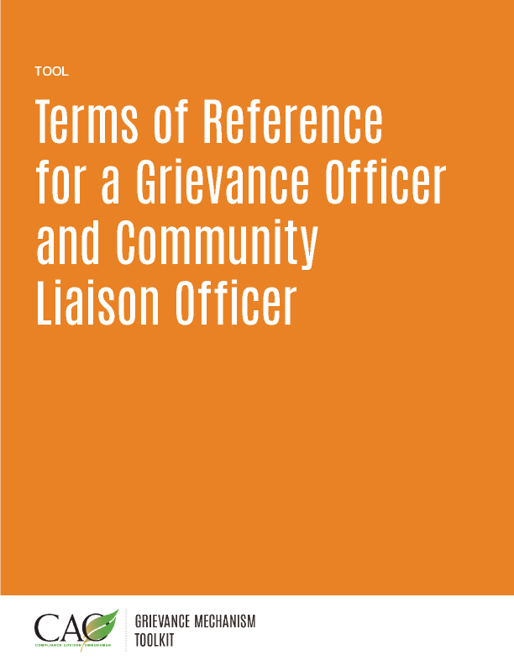

Last updated: May 2016
Key Requirements and Characteristics for Company Staff Managing Community Complaints
The individuals tasked with managing a grievance mechanism often feel that community members consider them to be too closely aligned with company interests, while co-workers view them as too strongly representing and advocating for the interests of community members. For many Grievance Officers, communicating and justifying actions within the company can be more difficult than communicating to external stakeholders. Therefore, company staff managing community complaints should strive to be transparent through open communication with community members, while also maintaining confidence and wielding influence internally.
A larger operation with a significant community footprint could have a dedicated staff member(s) whose responsibility is to manage community concerns (a “Grievance Officer”). Other operations may have a staff member(s) who is responsible for community engagement as well as management of community concerns (a “Community Liaison Officer” (CLO)). Both positions are aligned around three principal activities:
- Understanding
  - the project or operation and what impacts may result;
  - the social environment surrounding the operation; and
  - the needs and expectations of the company, the community and their representatives.

- Communication
  - to community members on how the grievance mechanism functions and how it can help them have a voice and seek redress.
  - to company staff on how the grievance mechanism can facilitate operations and how the grievance mechanism functions; and
  - how commitments resulting from the grievance mechanism are implemented.

- Informing and Promoting
  - the planning and decision-making process of the project/operation; and
  - continuous learning from complaints to improve operational performance.
To accomplish these objectives, the complaints handler must be able to:
- follow the specified grievance mechanism process when responding to the complaint and record activities related to the complaint;
- focus on substance and facts without speculating or making value judgements;
- understand the boundaries of the job and seek help when a situation may compromise his or her ability to perform assigned duties (for example, seek help when working on a complaint that could compromise other job duties, such as the day-to-day needs of engagement with critical community stakeholders);
- strive for equity in response to complaints and results of complaint assessment, such that if a particular resolution becomes known to others, it will be viewed as reasonable and consistent with how other complaints have been resolved; and
- maintain confidentiality if requested to do so by a complainant.
A. Terms of Reference for a Grievance Officer
The Grievance Officer serves as the focal point for the grievance mechanism. The Grievance Officer’s key roles are to capture community complaints and concerns systematically, address issues that can be readily resolved, refer issues to a complaint owner within the operation/company when substantive expertise is necessary, and follow up with both the complaint owner and community member(s) to ensure that the issue is resolved in a fair and timely manner.

Roles and Responsibilities

Manage the grievance mechanism

Receive community complaints and concerns and record them in a database.

Resolve complaints and concerns as appropriate.

Assign complaints that cannot be resolved by the Grievance Officer to a complaint owner within the operation.

Follow up with complaint owners to ensure complaint resolution is advancing in a timely manner and using a fair process.

Update complaint information in the database regularly.

Review complaints regularly and close them out when appropriate.

Monitor any resolutions to grievances to ensure they are implemented.

Engage with stakeholders

Provide information about the grievance mechanism to community stakeholders.

Inform management of concerns and complaints received by the grievance mechanism.

Work with operations staff to notify community members of activities that may lead to community concerns or complaints before the company undertakes the activities.
  - Work with staff tasked with community engagement to understand community issues before, during, and after community engagement events.

Experience and Qualifications
- Knowledge of the basic elements of the business operations
- Strong customer service focus
- Excellent communication skills
- Ability to work independently and with teams
- Ability to work on issues that may lead to conflict or be emotionally charged
- Mastery of computer skills sufficient to maintain a database of community complaints, and prepare reports and presentation of results

B. Terms of Reference for a Community Liaison Officer

The Community Liaison Officer (CLO) builds and maintains relationships with community members to better understand community concerns and perceptions. The CLO serves as the principal link—and thus also a critical communications channel—between the project operation and community members. The CLO is also responsible for implementing the grievance mechanism, including managing day-to-day activities and addressing community concerns when appropriate.

Operational Focus
- Gain a thorough understanding of the project operation.
- Understand potential impacts of the operation on the local environment, economy, and society.
- Interact with departments within the operation and inform staff of community relations activities and community concerns.

Utilize data and information from the grievance mechanism to develop lessons learned that are communicated to operations staff and communities as appropriate.
- Assist operations staff with utilizing lessons learned from the grievance mechanism to guide continuous improvement of operations.

Community Focus
- Gain a thorough understanding of local socioeconomic conditions.
- Build and maintain relationships with local stakeholders (such as neighbors, government, business and religious leaders, community organizations, and nongovernmental organizations).
- Provide information about the project operation to the community.
- Understand community perceptions of the operation.
- Recognize issues within the community that may result in heightened concern or unrest, and thus provide an early warning system on community issues.
- Facilitate engagement between operations staff, contractors, visitors, community members, and local officials and representatives, as needed.
- Manage social initiatives undertaken by the operation.

Management of the Grievance Mechanism
- Oversee implementation and operation of the grievance mechanism.
- Resolve complaints and concerns as appropriate.
- Assign a complaint owner within the operation to manage complaints that require technical or substantive expertise, as necessary.
- Work with complaint owners to help identify options for complaint resolution, as necessary.
- Track and document the complaint resolution process.

Develop and maintain the grievance mechanism database.

Perform data analysis and reporting.

Experience and Qualifications
- Knowledge of the elements of the business operations
- Deep knowledge of potential conflict points for the company and community
- Strong customer service focus
- Excellent communication skills
- Ability to work both independently and within teams
- Ability to work on issues that may lead to conflict or be emotionally charged
- Ability to influence decision making at all levels
- Mastery of computer skills sufficient to maintain a database of community complaints and prepare reports and presentation of results

